# Miniassignment 1

## XML loading:

1. Created a database called “miniassignment”. 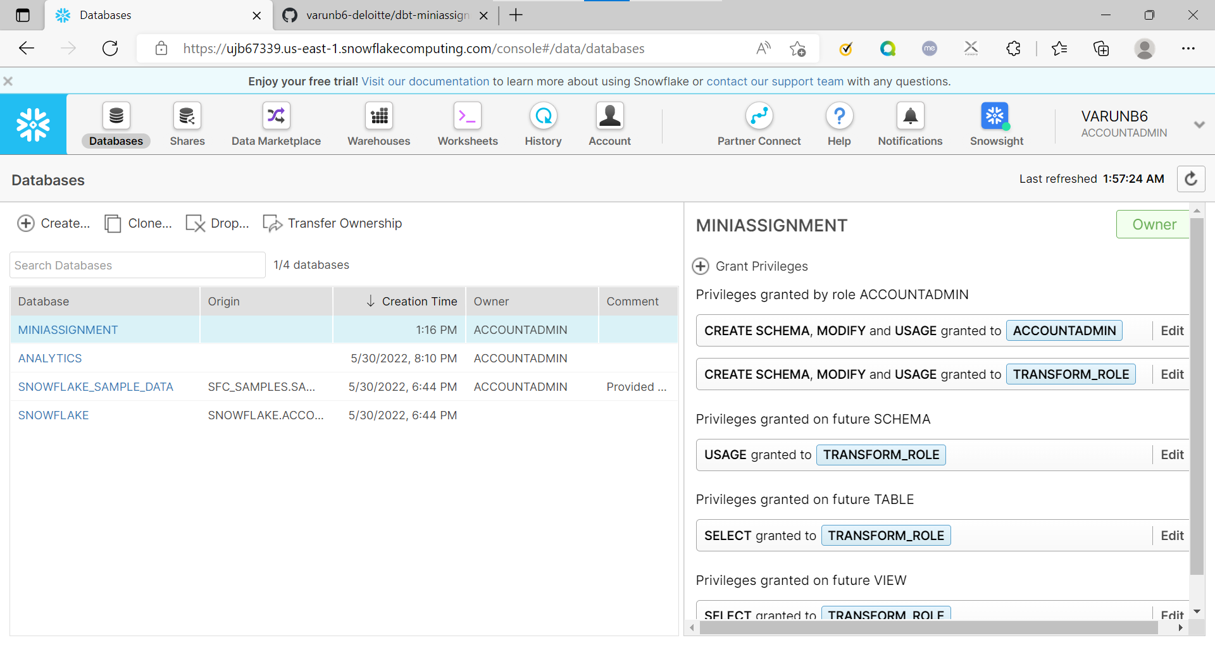
2. Created a table for users. 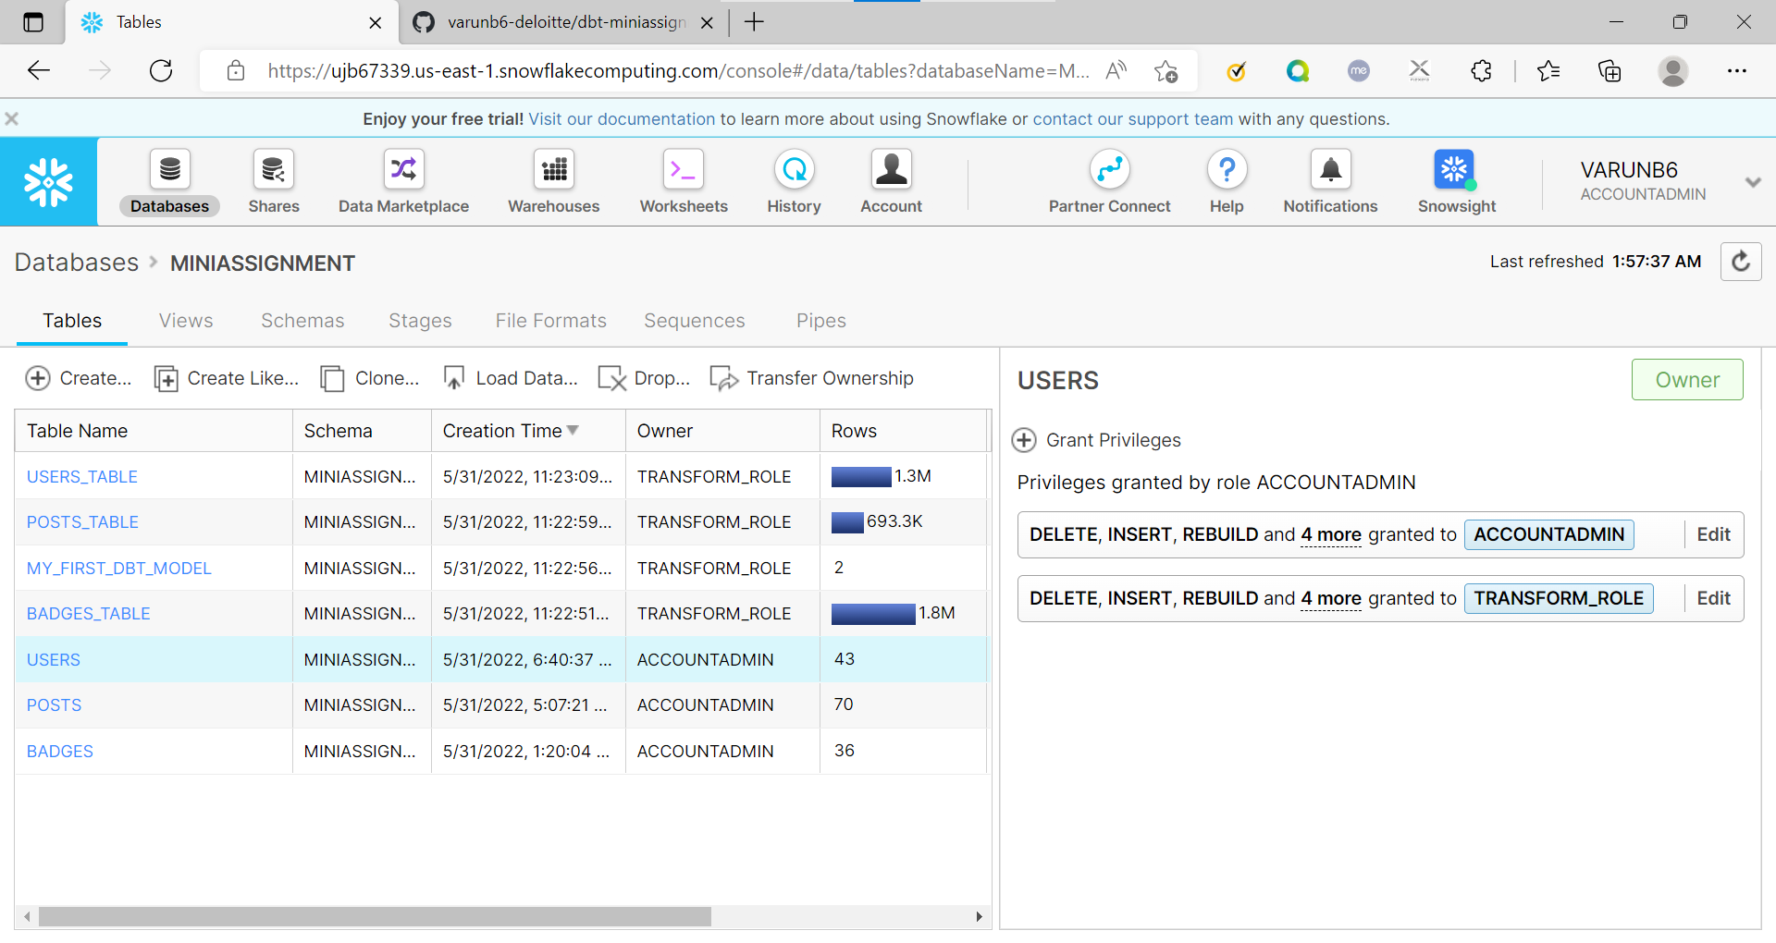
3. Loaded the xml data into table using the web ui. 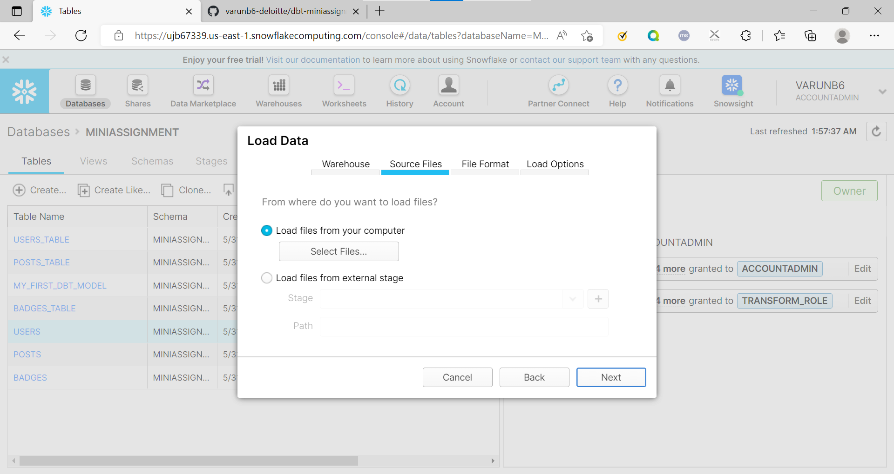
4. Configured file format as xml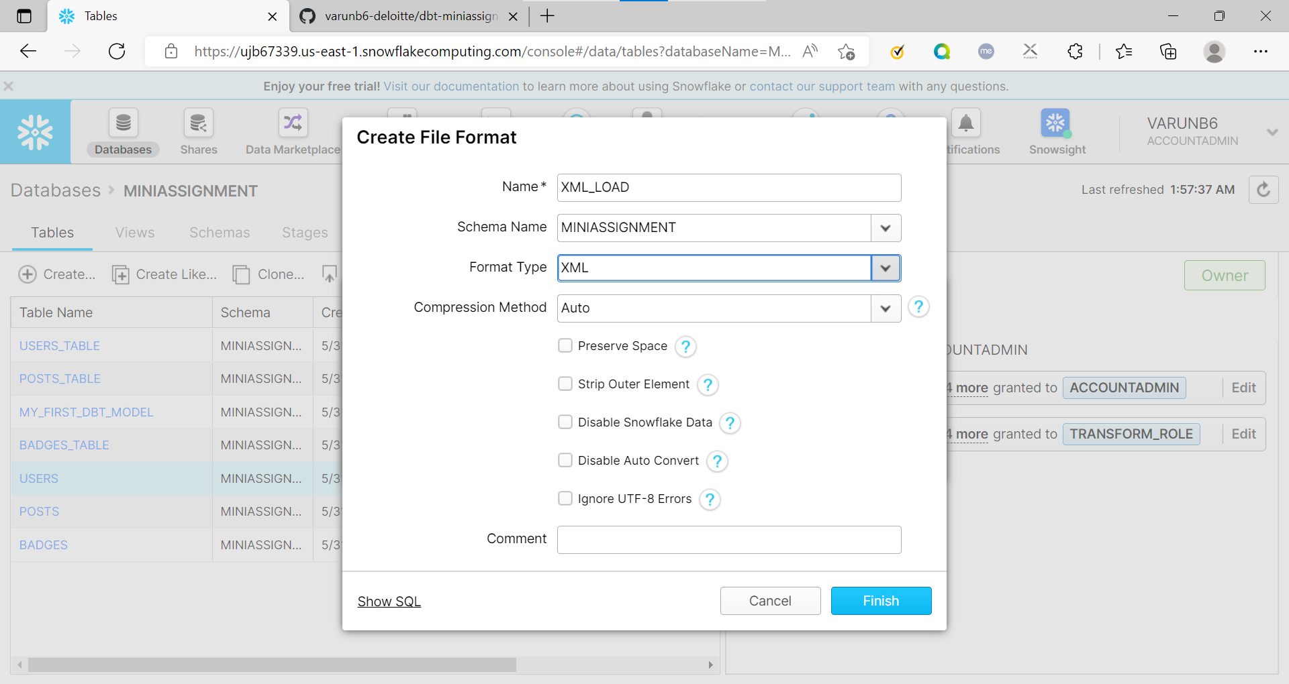
5. Likewise created “posts” and “badges” tables.
6. Created transformation for loading xml data from badges, users and posts table.

Badges: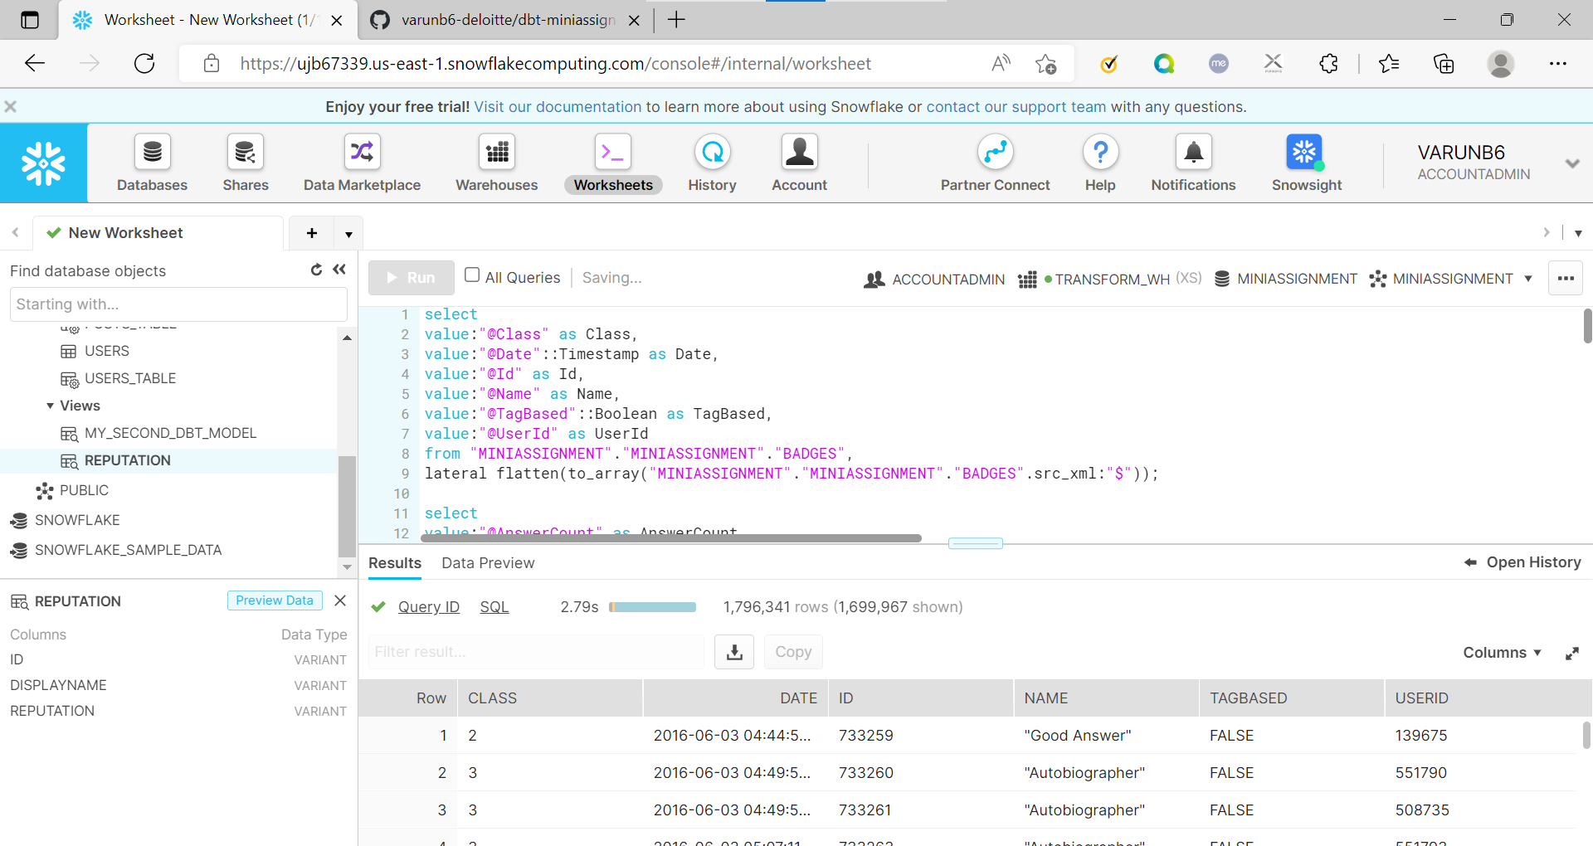

Users: 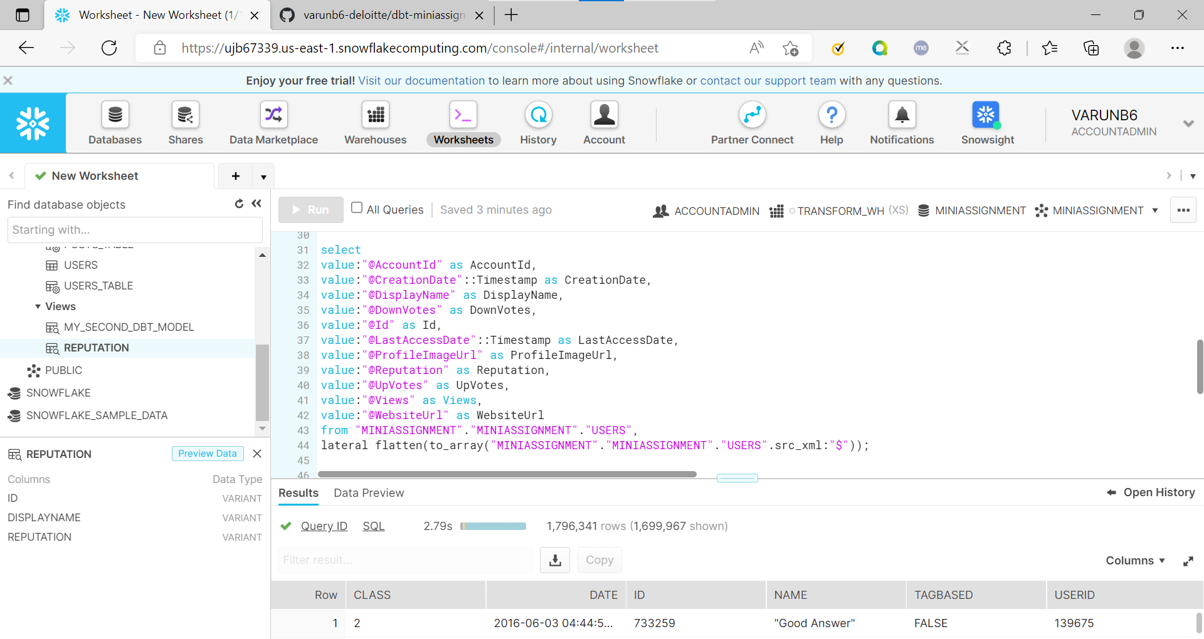

Posts: 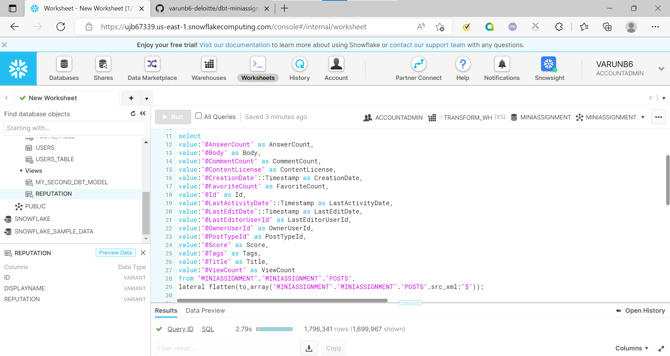

## Query 1:

select Id,DisplayName,Reputation

from {{ ref('users')}}

order by Reputation

desc limit 10

## Query 2:

select p.Body

from {{ref('users')}} u join {{ref('posts')}} p

on u.Id = p.OwnerUserId

where u.DisplayName = 'alexandrul' and p.PostTypeId = 1

## Query 3:

select p.Body

from {{ref('users')}} u, {{ref('posts')}} p

where u.DisplayName like '%nau%' and p.PostTypeId = 1

## Query 4:

select Name, count(UserId) as cnt

from {{ ref('badges') }}

group by Name

order by cnt desc limit 10

## Query 5:

select u.Id, u.DisplayName, u.Reputation, count(*) as num_questions

from {{ ref('users') }} u inner join {{ ref('posts') }} p

on u.id=p.OwnerUserId

where p.PostTypeId = 1 and u.Reputation > 75000

group by u.id, u.displayName, u.reputation